**Organised Events on the Cotswold Way**

To ensure your event runs as smoothly as possible, please complete and email this form to [cotswoldway@cotswoldsaonb.org.uk](mailto:cotswoldway@cotswoldsaonb.org.uk). The information you provide will enable the National Trails Team, other event organisers, local communities and landowners to manage their activities alongside your event.

It is better for everyone if you tell us about your event as soon as possible, even if a few details are yet to be confirmed. Also add your event to our website events listing and interactive map as a means of promoting your event but also to help others plan around your event – [www.nationaltrail.co.uk/cotswold-way/add-data](http://www.nationaltrail.co.uk/cotswold-way/add-data)

The future of events on the Cotswold Way relies upon ongoing repair and improvements to the Trail. Register your donation to help this work through this form. Donors can also benefit from promotion and engagement of local audiences and visitors through the National Trails Team and Cotswold Trails and Access Partnership.

Further details are available on [www.nationaltrail.co.uk/cotswold-way](http://www.nationaltrail.co.uk/cotswold-way) or call 01451 862008

**STEP 1: Complete this table.**

|  |  |
| --- | --- |
| Name of your event |  |
| Organisation managing the event |  |
| Charities to benefit from any fundraising linked to event |  |
| Event website address |  |
| Named contact during the event, in case of emergencies or problems | Name(s):  Phone number(s): |
| Named contact for general enquiries before and after event | Name(s):  Phone number(s):  Email: |
| Participant activities, i.e. walking, running, |  |
| Start date and time (earliest) |  |
| Finish date and time (latest) |  |
| Estimated total number of participants (use previous events’ totals as a guide) |  |

|  |  |
| --- | --- |
| Can you accommodate less able bodied participants? | Yes No |
| Do you plan to provide discounted entry or other offers to people living near the Cotswold Way? | Yes No  Not applicable – no entry charge for this event |
| To help us work together to promote your event and spread messages via social media, please tell us your social media account names etc.  Please link up to our Twitter: @CotswoldsAONB | Twitter:  Facebook:  Other: |
| Approximate amount and date you will provide a donation. We will be in touch to discuss specific arrangements. | Note: Suggested minimum donation £1 per participant. |

**STEP 2: Provide/produce an event map**

Please provide a map to accompany this form showing:

* Highlighted route(s) to be followed by participants
* Start point(s)
* Finish point(s)
* Intermediate checkpoints/venues

If you do not have an event map, please create one. It is possible to annotate and print off Ordnance Survey maps at various scales showing National Trails from [www.magic.gov.uk](http://www.magic.gov.uk). The MAGIC website provides a tutorial on producing a map, but note that National Trails are found under the ‘Access’ tab. You can add labels showing event locations on your computer or on a printed map. The National Trails Team cannot cater for requests for maps to annotate, sorry.

**STEP 3: Read this important notice**

We encourage events on the Cotswold Way that are well-organised, well-received by all and do not have unsustainable impacts on the Cotswold Way. All events must have appropriate Public Liability Insurance and risk management. To help you make your event the best it can be, we provide a guidance document and pass on feedback we receive about your event. Event organisers can seek permission to use the National Trails logo(s) where their event demonstrates good practice and an appropriate donation is made.

**STEP 4: Email completed form, event map and any promotional material**

(e.g. event flyer, promotional photos, event logo) to [cotswoldway@cotswoldsaonb.org.uk](mailto:cotswoldway@cotswoldsaonb.org.uk)

**Do this as much in advance as possible.**

**STEP 5: Add your event to our website**

[www.nationaltrail.co.uk/cotswold-way/add-data](http://www.nationaltrail.co.uk/cotswold-way/add-data)

A step-by-step guide is provided at the end of this form to help you add your event.

Your Name

Signature

Date

**Additional comments or information you may wish to provide:**

|  |
| --- |
| ***www.nationaltrail.co.uk*** |

**How to add information to the website**

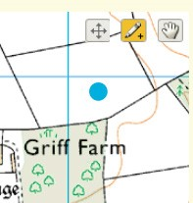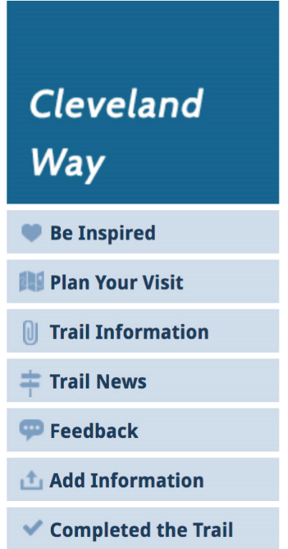

1. First sign up or sign in by clicking the Login or Join button at the top right of the page;
2. Once you are signed in, from the National Trails tab select the Trail that the entry you want to add is closest to. From the Trail page click on ‘Add information’ on the left hand side of the page.
3. From the Add information page click on the relevant button to add your information.
4. Fill out the form ensuring that you complete all fields marked with a star.
5. It is important to enter a location otherwise your entry won’t appear on the map. To do this please follow the instructions below:
   * enter the postcode or street name and town/city into the Search address box and then select the correct option that appears;
   * a blue dot will appear on the map. If the dot isn’t in the right place select the drawing tool (pen with a + sign) at the top right of the map and drag the dot to the correct location. Once you have placed the dot in the correct position it’s advisable to click on the hand icon (next to the drawing tool) so that you don’t accidentally move the dot;
   * check the address listed in the Full address box is correct as this is the address that will appear on the website (editing the details in this box will not affect the position of the dot on the map);
6. When you are finished click the ‘Save’ button at the bottom of the page. Your entry will now appear on the map.

# How to view your entry on the map

To see your entry on the map click on Plan Your Visit.

* If you added an attraction or point of interest click on the ‘Attractions / Point of Interest’ check box situated below the map;
* If you added a photograph click on the ‘Photos’ check box;
* If you added an event click on the ‘Events’ check box;

Once you select the relevant check box a marker will appear on the map with your entry. Click the marker to see more.

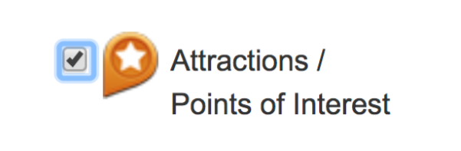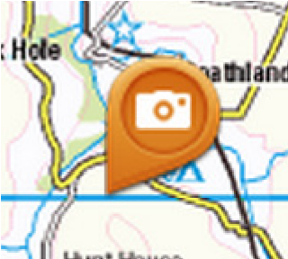

# Updating or editing your entry

You can go back and edit your entry at any time by signing in and clicking the My account button at the top right of each page.

If you need help adding information to the website please email **nationaltrails@walk.co.uk**