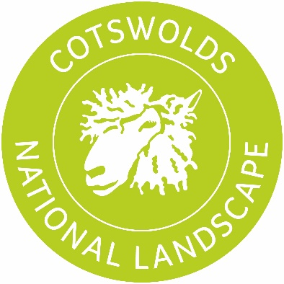

**Caring for the Cotswolds – Application Form**

Please refer to the guidance when completing this application form.

**Section 1. Applicant’s details**

Yes / No

Name of organisation

Name of applicant

Position in your organisation

Contact address

(Including postcode)

Contact telephone number

E-mail address

Type of organisation

Are you VAT registered?

Describe your organisation

**Section 2. Project details**

Project name:

1. Location of project (or nearest postcode/what3words)

2. Please give a brief description of your project for which you are applying for funding.250 word limit

3. Explain which of our themes your project will focus on. 500 word limit

4. How will your project be accessible to the public?

5. Please list any permissions that are required before the project can start.

**Section 3. Project management**

|  |  |
| --- | --- |
| **Milestone** | **Date** |
| Project start date | month/year |
| Add milestone |  |
| Add milestone |  |
| Add milestone |  |
|  |  |
|  |  |
| Project end date | month/year |

6. How will you measure the success of your project? 250 word limit

7. Who will maintain the completed project and how will this be resourced in the future?

8. How will you acknowledge and publicise a Caring for the Cotswolds grant?

9. How did you find out about Caring for the Cotswolds?

**Section 4. Applying**

Applications must be submitted electronically by email to [nina.stubbington@cotswoldsaonb.org.uk](mailto:nina.stubbington@cotswoldsaonb.org.uk)

Hard copy applications are not accepted.

Applications must include a project budget and any additional information that will support your application.

**Applicant’s declaration**

“I certify that that all the information provided in this application is true to the best of my knowledge. I certify that I am the applicant or I have the applicant’s authority to submit this application. I understand that any misleading statements could make the application invalid and therefore liable for the return of any money.

I also understand that any information submitted will be made publicly available and may be used by participating businesses and the Cotswolds Conservation Board to promote the scheme. I am prepared to have project descriptions placed in the public domain and to provide text and images for this purpose.”

Name:

Signed:

Date: