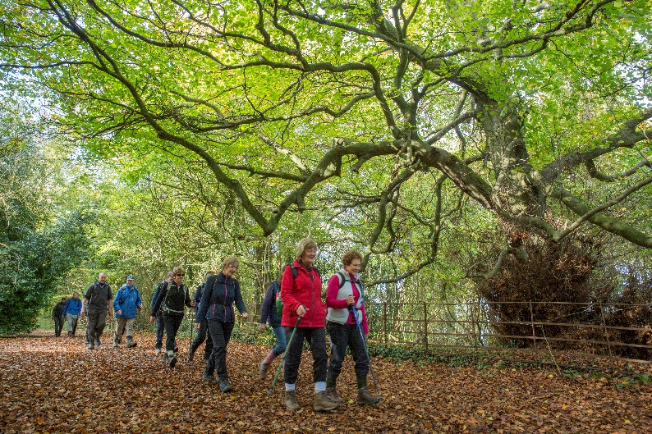 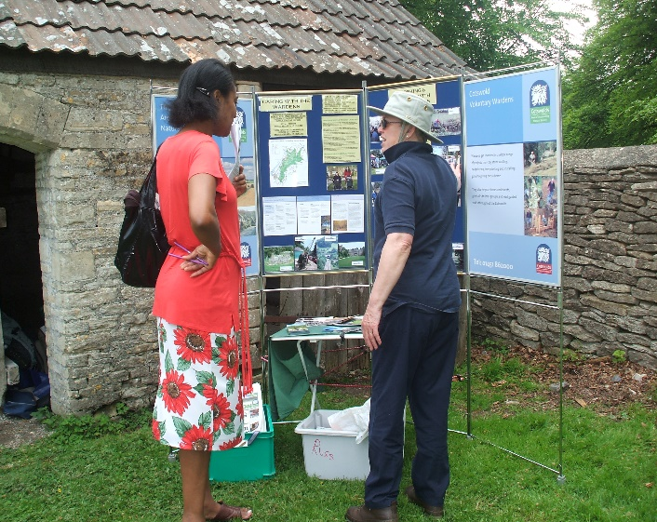 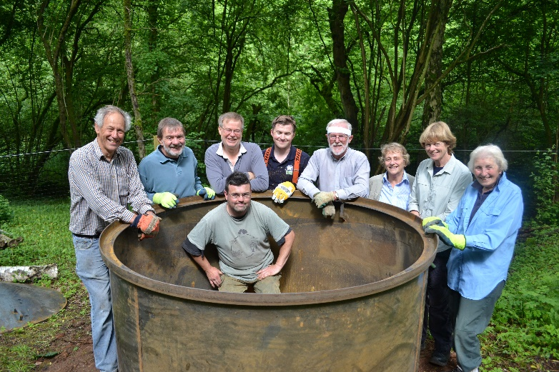 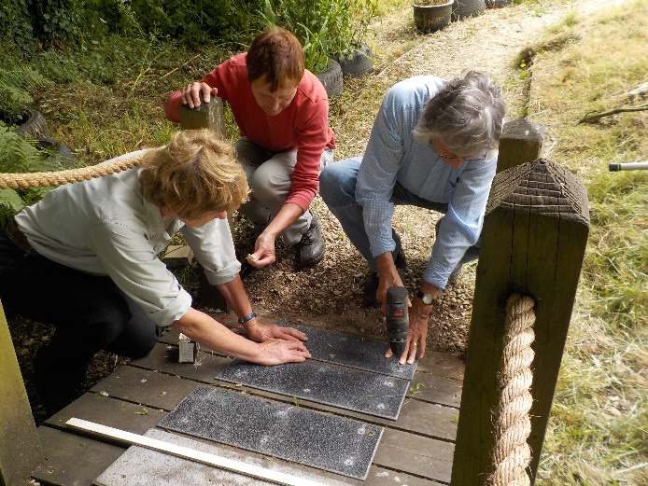

Cotswold Voluntary Wardens help to look after the Cotswolds National Landscape.

www.cotswoldsaonb.org.uk

**Thank you for expressing an interest in the Cotswold Voluntary Wardens who help look after the Cotswolds National Landscape.**

**The Wardens are the voluntary arm of the Cotswolds Conservation National Landscape team who manage the area and are funded by DEFRA and Local Authorities within the area.**

**Please read the information provided and complete and return the application and GDPR forms if you feel able to offer an average of eight hours of your time a month. In return you will receive training, support and a sense of achievement.**

**ACTIVITIES**

**Working in your parish**

Voluntary Wardens are a vital link between the Cotswolds National Landscape and local communities. As a Parish warden you will help to look after a local parish; walking the paths and helping to improve access and the local environment. The role is flexible and ideal for someone who would prefer to volunteer at a time that suits them. Many parish wardens get involved with talking to the parish council, farmers, local people and visitors and may also wish to get involved with local projects such as dry stone walling and tree planting.

**Guided walks**

Voluntary Wardens plan and lead hundreds of guided walks and other events throughout the year for members of the public. They provide relaxed and informative introductions to many aspects of the Cotswolds, including heritage, folklore and wildlife. As a walks leader you build upon your knowledge of the area and even specialise in areas that interest you such as flowers or local history. Leading walks is a very social role, working with other wardens and an opportunity to engage with the public and share your enthusiasm.

**Work parties**

Work parties are the voluntary ‘muscle’ of the Cotswolds, working on access and conservation projects. This could include planting trees, laying hedges, restoring historic features, working on dry stone walls, clearing ponds, putting up bat boxes and maintaining rare limestone grassland. Work parties help keep footpaths and bridleways open, replace stiles with gates, build and repair footbridges, clear undergrowth and waymark paths.

**Communications**

Voluntary Wardens are often the public face of the National Landscape at a local level. Wardens can get involved with social media promotion, attending shows and events, giving talks to local groups, writing articles for publications, taking photos distributing literature and working with the local media.

**Education**

An immensely rewarding opportunity for Wardens to work with schools and younger groups introducing children and young adults to the importance of the Cotswolds and their environment.

**VOLUNTEER ROLE DESCRIPTION**

**Responsible to:**

Becky Jones, Access and Volunteer Lead

**Purpose of the role:**

The Cotswolds Area of Outstanding Natural Beauty (now National Landscape) was designated in 1966 under the National Parks and Access to the Countryside Act. The Cotswold Voluntary Wardens were established in 1968 to support and achieve the aims of this designation. They give more than 48,000 hours of their time each year to conserving and enhancing the Cotswolds and improving access.

**As a Cotswold Warden, you will;**

1. Offer an average of eight hours per month as a Cotswold Voluntary Warden, recording these hours on a quarterly basis.
2. Act as an ambassador for the organisation in their chosen role when communicating with the public, landowners and other organisations.
3. Comply with Health and Safety regulations; taking into consideration those working with you and members of the public. Potential hazards, accidents and other relevant issues must be reported to the Access and Volunteer Lead.
4. Take responsibility for any tools and equipment provided to you for your role.
5. Attend introductory workshops and first aid and safety training courses every three years.
6. Attend quarterly meetings of the Cotswold Voluntary Wardens and other committee and activity meetings.
7. Respect all other wardens and staff at all times.

**The Cotswolds National Landscape will;**

1. Provide all the necessary tools and equipment for you to carry out your role.
2. Reimburse mileage costs and committee expenses (currently 18p /mile and 22p /mile car share)
3. Provide all the necessary training and insurance for your chosen activity

**For further information or an informal chat please contact: Becky Jones on** 07738040456 or email at**:** [**rebecca.jones@cotswoldsaonb.org.uk**](mailto:rebecca.jones@cotswoldsaonb.org.uk)

Personal Information

Surname: ………………………………………………. Forenames: .........................................................................

Title: ………………………………………………….…..   Date of Birth: …………..………………………………………………

Address: …………………………………………………………………………………………………………………………..………………………

……………………………………………………………………………………………………………………………………………………………….

Postcode: ………………………..……………

Best contact Number: Day …………….…………………………… Evening ……………………………………………..

Email Address: ……………………………………………….……………………………………………………………………………………..

Emergency Contact Details (in case of an incident whilst on warden activities): ........................................................................................................................

……………………………………………………………………………………………………..……………………………………………………….

……………………………………………………………………………………………………………..………………………………………………..

Do you have eight hours per month to offer as a Voluntary Warden? Choose Yes or No.

What days would you generally be available to volunteer?

Have you any restricted health factors that you would like to let us know about? Choose Yes or No.

If yes, please give details:

………………………………………………………………………………………………………………………………………………………………………………………………………………………………………………………………………………………………………………………………………………

How did you hear about the Voluntary Wardens?

………………………………..……………………………………………………………………………………………….

Are you a member of any other volunteering group? Choose Yes or No.

If yes, please give details:

………………………………………………………………………………………………………………………………………………………………………………………………………………………………………………………………………………………………………………………………………………

Do you hold a current driving licence? Choose Yes or No.

If yes, do you have car insurance that covers you for volunteering activities? Choose Yes or No.

About you

What activities interest you? Please tick one or more of the following:

Parish Patrolling  Communications  Guided walks

Administration  Practical conservation and access work  Education

Please tell us about any training, personal interests, hobbies, professional skills and experience that you feel are relevant;

…………………………………………………………………………………………………………………………………………………………………………………………………………………………………………………………………………………………………………………………………………………………………………………………………………………………………………………………………………………………………………………………………………………………………………………………………………………………………………………………………………….……………………………………………………………………………………………………………..………..…………………………………………………………….

Convictions

Have you been convicted of a criminal offence*? Choose Yes or No.

If yes, please give details:

*Convictions which are deemed spent under the Rehabilitation of Offenders Act (1974) need not be disclosed.

……………………………………………………………………………………………………………………………………………………………………………………..…....………………………………………………………………………………………

Thank you for completing this form. Any information provided will be treated as confidential.

**Declaration:**

I confirm the above information to be correct and acknowledge that an untruthful statement made by me will prejudice my application, and if appointed, may result in my dismissal.

Signature: ……………………………………………………….. Date: ……………………………………………….

**Please send your completed form to:**

**Email:** [info@cotswoldsaonb.org.uk](mailto:info@cotswoldsaonb.org.uk)

Becky Jones, Access and Volunteer Lead, Cotswolds National Landscape, Cotswold Business Centre, 2 A P Ellis Road, Upper Rissington, Gloucestershire. GL54 2QB

For any queries: **Tel: 07738 040456** (answerphone for out of office hours)

Dear Cotswold Warden

**DATA PROTECTION**

Data Protection legislation has changed recently and the Cotswolds National Landscape (hereinafter referred to as the Board) needs to inform you about how they handle your personal information.

What information the Board holds and why they are holding it

In order to communicate with you as a Cotswold Voluntary Warden, The Cotswolds National Landscape holds a record of your name, address, phone number and email address. You have provided this information to us when you applied to join, along with a date of birth for insurance purposes and emergency contact details in case of a problem whilst on warden activities. You also informed us whether or not you have any health restrictions and / or criminal convictions. These details are used by the Board staff to assess risk to other volunteers and the public, and may limit activities available to you as a Warden.

The Board keeps this personal information on a secure server to which only authorised staff have access. Paper copies of your membership form are held by the Board in a locked cabinet. The District Membership Officer and district committee members will securely hold your contact details in order to make these available to other Wardens to help the Wardens carry out their activities efficiently.

The information may be used to verify your membership to others who need to know, such as our insurer, to book training with commercial providers, or to confirm with landowners, schools or Parish Councils that you are a Warden.

For those making expenses claims, the Board requires account details that are held securely by our payroll provider Publica at the Cotswold District Council. The Board will keep these details until your first expenses payment has been made, after which they will be securely destroyed.

If you participate in activities such as work with schools, the Board and schools may require a Disclosure and Barring check, but the Board will only retain a record of the approval date.

The Board is legally obliged to document the lawful basis for holding the above information. Originally when you applied to join the organisation, you provided the information with your consent. Under the new legislation the Board intends to hold the information under the provisions of Public Task – i.e. it is necessary for us to perform a task in the public interest or for the Boards official functions. This is because you are entitled to withdraw your consent for the Board to hold personal information, but if you do so, we cannot discharge our responsibilities properly.

Wardens’ website and informal contacts

The Board will post extracts from the membership lists on the Wardens Area of the Cotswolds National Landscape website for access only by Wardens who are registered for accounts. This helps Wardens contact you with regard to Wardens activities.

None of the information that you have provided to us will ever be sold or passed on to third parties. Your information will be removed from our database and your application form destroyed when you cease to be a Warden, with the exception of a name and date of service to the Wardens, for historical records purposes.

In order to allow me continue to hold your information for this purpose and communicate to you as a Cotswold Voluntary Warden, please complete the form overleaf, and return to myself as soon as possible.

The Board’s Data Protection Policy should be read by all Wardens and can be found at <https://www.cotswoldsaonb.org.uk/about-us/data-protection/>

You may ask to see what information I have and I must provide it. You can also ask for it to be changed and updated where you know it to be incorrect.

In order to ensure that we have up to date emergency contact details, please could you also provide them along with your consent.

**If you no longer wish us to hold your personal information for the purposes of warden activity on the website or do not wish to continue as a Cotswold Voluntary Warden then please email or write to me.**

Yours sincerely

Becky

Becky Jones

Volunteer Coordinator

Cotswolds National Landscape

**GDPR & Image Consent Form**

Please complete the consent form below and email to [info@cotswoldsaonb.org.uk](mailto:info@cotswoldsaonb.org.uk)   
**or** post to Rebecca Jones, Volunteer Coordinator, Cotswolds National Landscape, Cotswold Business Centre, 2 A P Ellis Road, Upper Rissington, Gloucestershire GL54 2QB

**or** hand a completed copy to your District Membership Officer

**Apologies but there may be incompatibilities with Apple devices and so if you have problems with the boxes or entering text, you may have to print, complete and email a scanned copy to me.**   
  
------------------------------------------------------------------------------------------------------------------------------

**Consent Form**

Your Full Name: …………………………………………………………………………………….

*Please type / write your warden district in below:*

District: ……………………………………………..

*Please tick the box below if you wish to continue for us to hold your information and continue as a Cotswold Warden.*

1. I accept that my membership of the Cotswold Voluntary Wardens requires the Volunteer Coordinator to hold my personal data (name, address, email address, phone numbers, date of joining) to enable her to discharge her official duties, and to receive and pass bank account details to Cotswolds District Council to allow any claims to be paid to my account. Without this, I accept that my membership can no longer continue.

*Please tick the box below if you consent for us to publish your selected personal details on the wardens area of the website or delete the paragraph/indicate in writing if you do not wish for your information to be held on the wardens area of the website.*

1. I consent to the publication on the restricted access Wardens Area of the AONB website of my name, email address, phone numbers and town/village so that other Wardens can contact me in connection with Wardens activities.
2. I give consent to Cotswolds National Landscape to publish, republish, or otherwise transmit still and moving images, audio and my name for the purposes of:

• Publicity and promotional materials, including advertising material and printed publications

• Presentation and exhibition materials

• Websites, social media channels and digital communications materials, including advertising material and printed publications

• News media and their associated websites, social media channels, print publications, television and radio

I understand Cotswolds National Landscape will keep all its images in accordance with data protection law and delete the images that have not been used for any publicity or marketing until further notice or such time that you inform us that you do not wish your data to be stored by us.

I also understand that the still, moving images, audio used for publicity or marketing purposes are in the public domain and therefore could potentially be reproduced, altered, or re-used by anyone in the world outside of Cotswolds National Landscapes control.

I know I have the right to withdraw consent at any time by emailing [info@cotswoldsaonb.org.uk](mailto:info@cotswoldsaonb.org.uk) but understand that withdrawing consent may not affect the material that has already been used.

Emergency Contact Details:

………………………………………………………………………………………………………………………………………………………………………………………………………………………………………………………………………………………………………………………………………………………

**Name ………………………………………………… Signed …………………………………………………..**

**Date …………………………………………..**