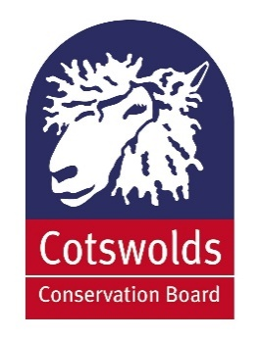

**Cotswolds Conservation Board**

**Communications Strategy   
& Outline Plan 2017–2020**

**Mid Point Review: November 2018**

***‘Engaging & influencing to action’***

**Contents**

1. Introduction
2. Our purpose
3. Our principles of good communication
4. Our identity
5. Core objectives
6. Core messages
7. Outcome priorities
8. Influencing
9. Our audience
10. External communication
11. Internal communication
12. SWOT analysis of current situation
13. Measuring success
14. Monitoring and evaluation
15. Communication tools
16. Photography

Annex 1. What did the previous Communications Strategy achieve?

Annex 2. Monitoring of Communications

Annex 3. Outline Plan 2017/18

1. **Introduction**
2. Communication plays a vital role in everything we do at the Cotswolds Conservation Board. This Communications Strategy & Delivery Plan builds on, and updates the former 2015 strategy. It highlights the direction the Board will take in order to deliver its aims and objectives. Officers, Board members and volunteers all share responsibility for communicating our role effectively, listening to our audiences and adapting our services and messages according to the outcomes of that engagement

Our Communication Strategy needs to:

* *state our intentions clearly and describe the strategy’s purpose;*
* *explain why we believe good external and internal communication, engagement and influencing are important;*
* *clearly articulate our priority actions and say how we will measure success.*

1. In a wider context, increasing austerity and pressures on public sector budgets have resulted in a greater need for the Board to raise its profile to new audiences and prove its worth to the public and private sector, as well as to residents and visitors.
2. **Our purpose**
3. The Board was established by Parliament in 2004 and has two statutory purposes:
4. to conserve and enhance the natural beauty of the AONB; and
5. to increase the understanding and enjoyment of the special qualities of the AONB.

In fulfilling these roles, the Board has a duty to seek to foster the economic and social well-being of people living in the AONB.

1. The purpose of the Communications Strategy:

* *provide framework that underpins all communications plans that are developed to support the work of the Cotswolds Conservation Board;*
* *reflect our desire to involve and influence people and organisations more effectively in project planning and delivery and decision marking;*
* *raise awareness and promote understanding of the work of the Board on a local, regional, national and international level, and to enable effective and meaningful two-way communication between the Board and its target audiences;*
* *help deliver the aims of the Management Plan, Business Plan and the Board’s policies.*

Advice on any of the content of this strategy is available from the Communications Officer.

1. **Our principles of good communication**
2. The Cotswolds Conservation Board will endeavour to produce communications that follow the principles of plain English, avoid jargon, and will be timely and concise. Communications will be tailored to suit targeted audiences’ needs and will be clearly identifiable as belonging to the Cotswolds Conservation Board or about the Cotswolds AONB.
3. Effective and efficient communication is essential to promote the work and role of the Board and to raise awareness and understanding of the importance of the Cotswolds AONB as an internationally important protected area. It is also becoming increasingly important in the current economic climate for the Board to raise its profile and prove its value to its core audiences.
4. All communication about the Board and the AONB should:

* *uphold our key purposes;*
* *be of a high consistent standard in terms of content and presentation and follow the Branding Style Guide;*
* *balance the audiences’ needs and understanding with the Board’s purposes, objectives and budget;*
* *use the most appropriate channels to reach the desired targeted audience;*
* *an honest and open two-way communication with all our audiences;*
* committed to confidentially where required;
* *have a clear, consistent and easily identified purpose and to call to action;*
* *professional, timely and accurate communication at all times;*
* *reflect a diverse audience and be easily accessible.*

1. All forms of communication between the Board and its audiences should always follow to the following principles:  
   * *clearly identify its source as the Board/AONB;*
   * *convey at least one core message and;*
   * *where possible, promote/ signpost to the website as a key source of information about the Board and the AONB.*
2. Communicating involves listening and consultation. The Board is committed to seeking views of all stakeholders to ensure that their opinions and ideas are reflected in our work.
3. The delivery of the Communications Strategy will be led by the Communications Officer with participation from officers, members and volunteers.
4. **Our identity**
5. The Board seeks to uphold an effective, confident and attractive identity that enables awareness, appreciation and familiarity. All information, regardless of format, should be consistent with and enhance the Board’s identity. All such information should be up to date, accurate and subject to regular review.
6. **Core objectives**
7. The overarching objectives for effective communication in this strategy are:
8. *influence targeted audiences in wider support of the aims, objectives, policies and guidance of the Board;*
9. *promote, raising awareness, enjoyment and understanding of the Cotswolds special qualities and its designation as an AONB and highlight the work of the Board and its partners;*
10. *deliver a strong fundraising theme throughout communication for one of England’s best loved landscape brands;*
11. *manage the reputation and identity of the Board/ AONB;*
12. *assist in the achievements of the Cotswolds AONB Management Plan and Business Plan.*
13. Good communications succeed in understanding an audience’s needs, defining the precise messages in a way that will be well received and understood and choosing the best channel in the marketing mix through which to communicate.
14. **Core messages**
15. The following messages form the main focus of what the Board communicates about itself and about the AONB in order to inform and influence our audiences. They provide a consistent foundation which can be edited or expanded to suit a particular audience or requirement. By using the following messages, Board members speak as one. Their purpose is to create a shared understanding. They are themes and concepts based on what we need to say about the Board, but do not need to be conscious to the letter.
16. Our messages:

**About the Cotswolds Area of Outstanding Natural Beauty (AONB):**

* *the Cotswolds AONB is a special place;*
* *everyone can benefit from the presence of the AONB;*
* *the Cotswolds AONB is the walking and exploring capital of England;*
* *we are a member of the AONB family, the protected landscapes family (AONBs and National Parks);*
* *the AONB is significant contributor to the economy in natural capital and tourism;*
* *a place that needs to be cared for with fundraising support;*
* *home to 2 of England’s National Trails – the Cotswold Way and the start of the Thames Trail;*
* *the Cotswolds AONB is one of the largest protected landscape in England following the Lake District and Yorkshire Dales National Parks ;*
* *part of an international family of protected areas and internationally recognised as an important landscape.*
* *Following the announcement of the Julian Glover Review of Areas of Outstanding Natural Beauty and National Parks, the Cotswolds AONB should be considered for re-designation as a National Park*

**The Cotswolds AONB is a special destination:**

* *a designated AONB in recognition of its high quality and diverse landscape;*
* *a place loved by millions for its natural beauty and rich historic and cultural heritage;*
* *a welcoming place for everyone to discover, explore and enjoy;*
* *home to a variety of internationally important habitats and wildlife;*

**Cotswolds Conservation Board:**

* *is an independent statutory organisation established by parliament to look after the Cotswolds AONB;*
* *is the only organisation to look at the AONB as a whole and to speak as one voice of the Cotswolds;*
* *working in partnership to conserve and enhance the AONB’s natural beauty;*
* *works to increase understanding and enjoyment of the special qualities of the AONB;*
* *seeks to foster the social and economic well-being of its local communities;*
* *is committed to working in a sustainable and consultative way;*
* *supporting a thriving sustainable economy, including sustainable tourism.*
* *is committed to its ambition of promoting the case for the Cotswolds being designated as England’s next National Park.*

1. **Outcome priorities**
2. Outcome priorities help to sharpen the focus of the Board, enable our objectives to be clearly understood and provide a clear structure for delivery. They are as follows:   
   * conservation and enhancement of the AONB improved, designation is better recognised;
   * Board is more influential and successful;
   * Board is seen to deliver innovative projects;
   * Board’s policies and governance widely adopted/used and the Board is recognised as an authoritative and trusted voice of the AONB landscape.
3. **Influencing**
4. The Board uses a number of tools to engage and influence its audiences. These tools include:

* Management Plan;
* position statements;
* landscape character assessments;
* Landscape Strategy and Guidelines;
* responding to consultations (e.g. Planning, Land Management);
* visits by Defra/agency visits;
* use of Section 85, Countryside & Rights of Way Act 2000, duty to have regard to the purposes of AONB designation (where relevant authorities have a duty to have regard to the purposes of AONB designation when carrying out their responsibilities / activities);
* forums (e.g. Annual, Farming and Access);
* select committees;
* social media (e.g. LinkedIn);

1. **Our audience**
2. The audiences of the AONB and Board, in terms of Communications, are wide and varied. Our key stakeholders are anyone who is involved with, has an interest in or is affected by the Board and its activities and include:

|  |  |  |
| --- | --- | --- |
| **Priority audiences influencers:** | **Political and media influencers:** | |
| * farmers and landowners; * funders; * government departments (e.g. Defra, DCMS); * local authorities/ parish councils; * MPs, MEPs and local authority leaders and members; * developers; * partners (e.g. Wildlife Trusts, Forestry Commission, National Trust, Natural England, Farming & Wildlife Advisory Group (FWAG), National Farmers’ Union (NFU). | * Campaign for National Parks; * EFRA Select Committee; * environmental bloggers; * Green Alliance; * Highways England; * National Association of AONBs and other AONBs; * National Parks; * National Parks England. * National Parks and AONBs Review 2018 Advisory Group | |
| **External audiences** | | **Internal audiences** |
| * businesses (e.g. visitor attractions); * local and national media; * residents in the AONB and residents living in urban buffering areas (e.g. Cheltenham, Gloucester, Bristol, Oxford, Stratford, Banbury); * suppliers and contractors; * visitors (domestic and international), walkers, cyclists, horse riders. | | * Board members; * employees, including contractors and work placements; * volunteers. |

1. It’s important that we have a good understanding of our audiences behaviour, emotions, attitudes or beliefs so that we know what and how they will respond to communication and devise the most effective means/ channel of communicating with them. There are four core sources: data, research, environment/ technology and relationships. We are able to gather some of this information from work we undertake but we also recognise that we need to undertake further work in order to be more effective in our communications with our different audiences.
2. **External communication**
3. The Board uses a variety of communication methods and channels to target individual audiences. To ensure successful communication, the Board should undertake regular reviews of all delivery methods, refining and strengthening these where appropriate. The Board is committed to confidentially where required.
4. **Internal communication**
5. Officers, Board members and volunteers (Wardens) are all ambassadors playing a crucial role in building our reputation. The way they behave and how they think about the Board can have a huge impact. Good internal communication is therefore highly important in helping us achieve our objectives.
6. The Board employs 28 members of staff (permanent and casual) who are all based at the office in Northleach. Around 300 active voluntary wardens contribute a significant number of hours of practical conservation and promotional work for the Board. There are 37 members of the Board, 15 of whom are appointed by local authorities, 14 by Secretary of State and eight nominated by parish councils.  Board members bring a diverse background of experience and a range of strengths and interests that help the Board carry out its duties.
7. Officers, Board members and volunteers are all representatives of the Board and the AONB, therefore good internal communication is essential to:

* *boost morale and motivation;*
* *be proud to act as ‘ambassadors’ for the Board;*
* *help create a ‘can do’ culture and build a committed and high performing organisation focused on achieving the Board’s objectives;*
* *provide an excellent customer service with informed staff up to speed with what’s happening in the Board;*
* *share and influence with networks and connections (e.g. Parish councils, local authorities, businesses)*
* *support the organisation to learn and be inspired, officers and volunteers are a vital source of information and ideas.*

1. All staff, Board members and volunteers receive regular e-newsletters, copies of the Cotswold Lion magazine and other relevant publications. Copies of all press releases are distributed via the Boards website. Regular Board, Executive and Sub-Committee meetings take place between members and appropriate officers, plus a monthly meeting takes place with the director and senior officers. The Cotswold Voluntary Wardens have regular meetings with volunteers across the AONB.
2. **SWOT analysis of current situation**

|  |
| --- |
| **Strengths** |
| * review of the current AONB Management Plan guiding activity for the next five years; * refreshing the series of promotional materials e.g. Explore by Public Transport Guide, * experienced staff team with specific knowledge and understanding; * a well-established identity; * good quality publications e.g. Cotswold Lion magazine, Visitor Map & Guide; * grant funding presented by the Board - opportunities in Visitor Giving, SDF and LEADER for projects; * a good awareness/profile with milestones located on key entry points into the AONB; * our volunteers - the Cotswold Voluntary Wardens and the impact the wardens have on the AONB over the past 50 years; * a good working relationship with the Cotswolds VICs/TICs; * the Cotswolds Discovery Centre has given Board/AONB a ‘shop window’; * LEADER goes outside AONB, extends our reach, engages new partners, demonstrates our interest in/ ability to deliver across the social/ economic agenda; * unique visitors to the Board’s websites continue to increase; * 2016 the AONB celebrated 50 years since becoming a designated area with successful engaging events and activities e.g. Cotswolds Living Landscape Festival and Cotswolds Inspired Art Exhibition reaching new audiences face- to-face and on social media platforms; * Cotswold Lion publication as a magazine has strengthened its readership and potential advertising income; * social media continues to grow since 2015, the Board has increase its following on Facebook. |
| **Weaknesses** |
| * low general level of understanding nationally and locally of AONB – what it is, what it means; * AONB has low profile at some key visitor sites eg. Rollright Stones; * some confusion over the Board and the AONB (and other sub brands such as Visitor Giving and Cotswold Choice) house style and brand being very similar - could lead to confusion; * lack of outreach work in urban areas, reaching a more diverse audience in projects and volunteering; * low level of email addresses for farmers and landowners held on the database; * unsuccessful bid to HLF for funding the plans at the Old Prison. |
| **Opportunities** |
| * build on and refine established identity rather than re-invent and focus what the Board is good at; * cost effective print (fewer publications, bigger print runs) and timing of publications; * strengthened staff team – with Save Our Magnificent Meadows project (2014 -2017), Discovery Centre, LEADER, and Glorious Cotswolds Grasslands (2018 – 2021); * further developing the Cotswolds Discoverer integrated rail and bus ticket; * a part of the National Association for AONBs ‘brand’ identity - increasing awareness nationally – joint working with National Parks; * continue to build and develop relationships with local authorities; * smaller bids for new Interpretation at the Cotswolds Discovery Centre; * working closely with the Cotswolds DMO; * income generation – publications, websites, sustainable tourism initiatives; * step up fundraising opportunities with Visitor Giving and caring for the Cotswolds for new income generation streams. |
| **Threats** |
| * potential funding cuts; * Other organisations still sometimes working to different geographical boundaries e.g. ‘Gloucestershire Cotswolds’ and the ‘Oxfordshire Cotswolds’ – important to retain identity of the Cotswolds AONB and key messages in terms of protected landscape; * Other environmental organisations chasing reduced funding resource, results in more competition. |

1. **Measuring success**
2. It is good practice to create outcomes of where the Board wants to be and not just to get stuck on the processes and objectives. By 2020 we want to:

* *have a better understanding of the percentage of residents, visitors and businesses who are well informed about why the Cotswolds is designated as an Area of Outstanding Natural Beauty;*
* *evaluate outcomes of how our messages and position statements are influencing our audiences (e.g. landowners, farmers); and*
* *measure impact of fundraising*

1. **Monitoring and evaluation**
2. The Communications Strategy should be monitored and evaluated regularly to gauge the effectiveness of the Board’s communications and ensure overall aims and objectives are being achieved.
3. This will be carried out by using the following tools:

* a new residents, visitors and landowners online survey, which is carried out every five years;
* monitoring the number of visits to the website along with the number of downloads and overall dwell time;
* regular monitoring of participant numbers on social media channels, reach and interactions using online tools;
* capturing and evaluating data from when issuing messages online (e.g. invite to forums, consultations) to targeted audiences to measure how we are engaging and influencing;
* evaluating response and interest in the Board’s position statements using Campaign Monitor;
* evaluating the quantity and quality of coverage received in the media, including the amount of take-up of news releases issued and video views on YouTube;
* evaluating attendance at events and encouraging feedback where appropriate, e.g. the Annual Forum, Farming Forum;
* monitoring response from advertisements by recording the take up of the advertised activity;
* monitoring comments, complaints and compliments received by the Board;
* a new internal survey among members, volunteers and officers should be carried out to determine any gaps in existing internal communications and identify areas for improvement;
* undertaking a marketing research survey among internal and external audiences every 2-3 years.

1. These tools are used to succeed communication goals, both external and internal, should be evaluated to measure their success. See Annex 2 – Monitoring of Communications.
2. **Communication tools**
3. Communication tools are employed to reach audiences. We aim to have a portfolio of tools in place, or knowledge and expertise available, so that through them we can:

* reach a local, regional, national and international audience;
* be up to date and relevant to the market;
* have a presence where our audiences are, for example landowner, planners and farmers;
* be accessible by providing a variety of formats (when appropriate);
* engage new audiences and keep building;
* be cost effective and realistic in delivering our messages and achieving our objectives.

1. The Board’s priority communication tools are:

* feedback: use all types of feedback to help inform future planning of projects and delivery;
* social media: use social media to monitor people’s experiences, satisfaction and changes in awareness;
* Campaign Monitor; use Campaign Monitor to issue key messages to audiences, capturing data on receiving, reading and responding to the message to enable the Board to have a better understanding of how we are helping to influence others with our objectives;
* website: use analytics to monitor visitors to the website, downloads, interactions and comments.

1. **Photography**
2. All images/film that are owned by the Board and that are used by external organisations must be credited as ‘Cotswolds Conservation Board’. When commissioning a photographer/videographer it is important to ensure that the Board will own the right to use the resulting images/film and that the agreement is reached on how to credit them and their use. This information should be kept with the photographs/film.

**Annex 1: What did the previous Communications Strategy achieve?**

1. The following actions have been achieved in the previous Communications Strategy.

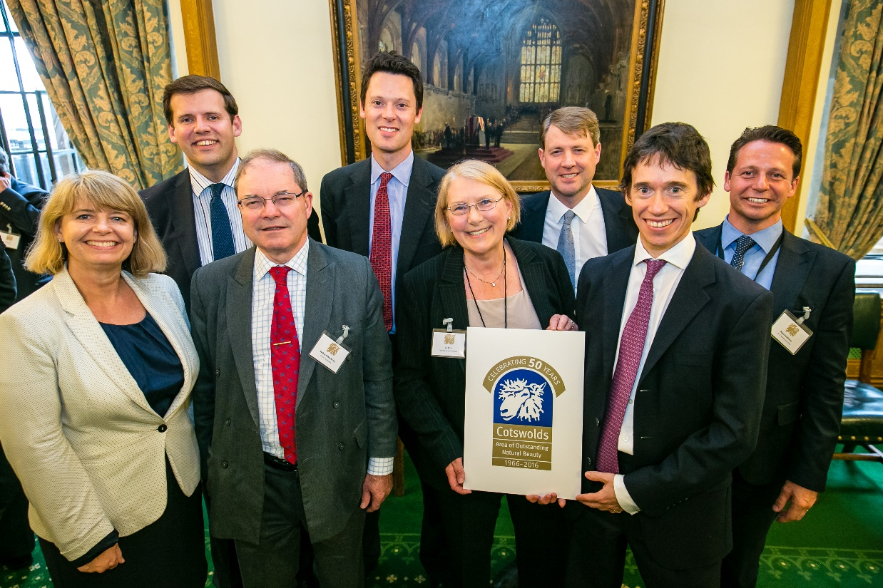

**Successful and engaging AONB 50th anniversary campaign in 2016:**

* forming new partnerships with over 100 businesses across the AONB;
* over 3,000 visitors at events organised directly by the Board;
* networking opportunities with Lords and MPs at Westminster reception;
* targeting new audiences; artists, local food and drink producers and farmers;
* the Cotswolds Living Landscape Festival creating new audiences on social media with a reach of over 140,000 interactions in just six months;
* series of products launched including book and beer.

**Growth in audiences on social media channels:**

* Facebook followers have grown from 1024 (2015/16) to 3,190 (2016/17) with a reach of 97,000 in 2015/16 increasing to 436,000 in quarters 1 to 3 in 2016/17.
* Twitter has seen an increase from 4,875 followers (reach of 470,000) in 2015/16 to 7,900 (reach of 556,000) in 2016/17;
* Introduction of LinkedIn company profile for the Board
* the introduction of video (YouTube) has seen 7,600 views in 2015/16 and 9,500 in 2016/17;

**New look and format of the Cotswold Lion publication as a 32 page magazine:**

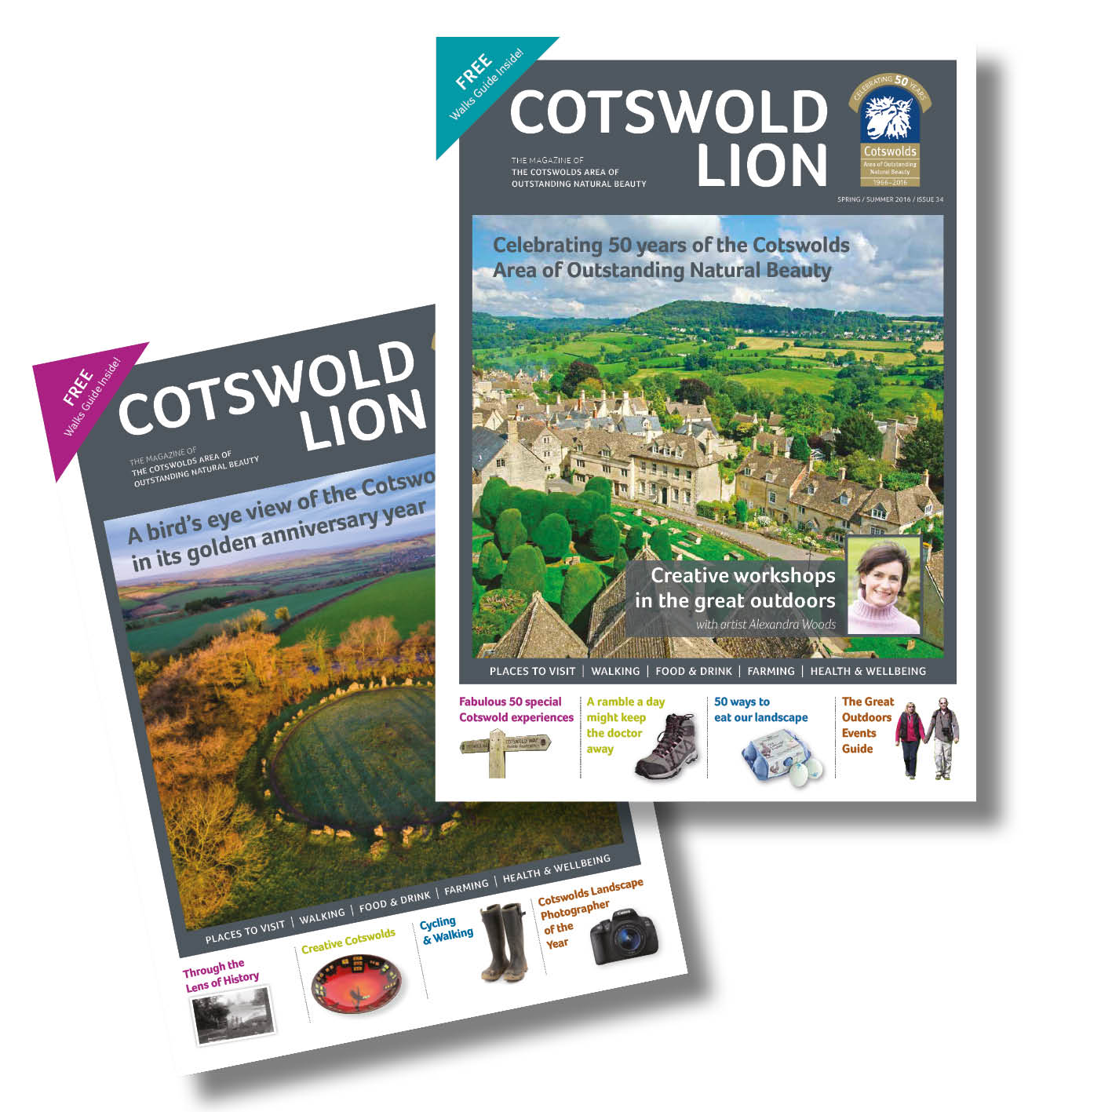

* Now reaching a wider distribution of venues, a longer lifespan to ‘take home and keep’ and more diverse and engaging features to reach new audiences and attract potential advertisers.

**Rebrand of the old prison site to the Cotswolds Discovery Centre;**

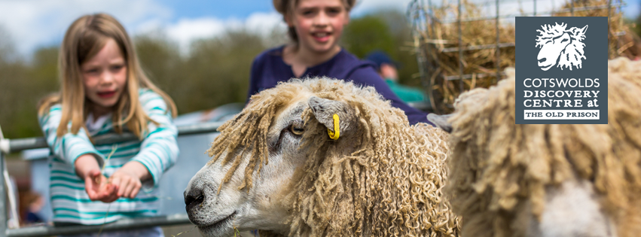

* new logo and branding;
* refreshed promotional leaflet;
* updated outdoor flags;
* new events including outdoor theatre and sheep and wool day events attracting over 1000 adults and children;
* refreshed social media presence.

**Refresh of the Cotswolds Discoverer Pass brand and focus on the one day pass as ‘the’ product**



**New video features using YouTube, Facebook and via the quarterly enewsletter updates.**

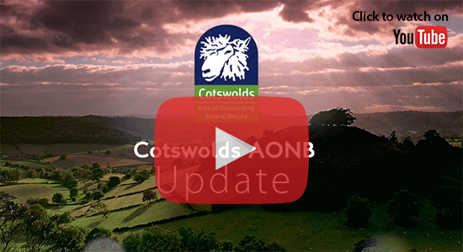

**Annex 2: Monitoring of Communications**

|  |  |  |  |
| --- | --- | --- | --- |
| **Monitoring of the uptake of Electronic Communications, Publications, Positions Statement** | | | |
|  | | | |
| **Item** | **Method of publication** | **Intelligence gained via Campaign Monitor** | **Intelligence gained from other monitoring** |
| **eNewsletter** | Campaign monitor / via website | * Receipt of document * Opening of document * Visits to pages, sections of document * Regularity of use of document * Forwarding of document to others | * Feedback from recipients/ users * Monitoring of website activity * Social media sharing * Comments via social media |
| **Videos** | Campaign Monitor  Facebook YouTube Twitter Vimeo  LinkedIn | * Receipt of video * Opening of video * Forwarding of video to others * Views of video * How long the video is watched | * Feedback from recipients/ users * Monitoring of website/social media activity * Social media sharing * Comments via social media |
| **Position Statements** | Campaign monitor / via website | * Receipt of document * Opening of document * Visits to pages, sections of document * Regularity of use of document * Forwarding of document to others * Sharing on social media | * Feedback from recipients/ users * Evidence of use in local plans, public inquiries * Monitoring of website activity * Campaign Monitor can be supplemented by Survey Monkey/Google Forms if required * Comments via social media |
| **Landscape Assessment and Landscape & Strategy Guidelines** | Campaign monitor / via website / limited print run | * Receipt of document * Opening of document * Visits to pages, sections of document * Regularity of use of document * Forwarding of document to others | * Feedback from recipients/ users * Evidence of use in local plans, public inquiries * Website use data, the Landscape Strategy & Guidelines is a mini site within the main website * Campaign monitor can be supplemented by Survey Monkey if required |
| **Management Plan & Executive Summary** | Campaign Monitor / via website / limited print run/ social media | * Receipt of document * Opening of document * Visits to pages, sections of document * Regularity of use of document * Forwarding of document to others | * Feedback from recipients / users * Evidence of use in local plans, public inquiries * Website use data * Campaign Monitor can be supplemented by Survey Monkey/Google Forms if required |
| **Social Media** | Facebook, Twitter, LinkedIn, YouTube |  | * Online tools to advise on:   + participant numbers   + reach   + interactions between users/ followers   + organic and paid for boosts |
| **Website** | Online/Social media |  | * Online tools to advise on:   + numbers of unique visits   + numbers of downloads of specific items or publications   + popularity of sections / pages   + overall dwell time * Advertising income |
| **Cotswold Lion magazine** | Print and via website/social media |  | * Feedback to the editor * Response to competitions via the website * Monitoring data from distribution company * Website use data * Advertising income * Comments via social media |
| **Explore the Cotswolds by Public Transport Guide** | Print and via website/social media |  | * Feedback from users, transport companies and venues listed * Distribution data * Website use data * Advertising income * Comments via social media |
| **Annual Review** | Print and via website/social media and Campaign Monitor | * Receipt of document * Opening of document * Visits to pages, sections of document * Regularity of use of document * Forwarding of document to others | * Feedback from recipients/ users * Website use data * Campaign Monitor can be supplemented by Survey Monkey/Google Forms if required |
| **Visitor Guide & Map** | Print and via website/social media |  | * Feedback from users * Distribution data * Website use data * Advertising income * Comments via social media |
| **Building Design Awards** | Print and via website/social media/ Campaign Monitor | * Receipt of document * Opening of document * Visits to pages, sections of document * Regularity of use of document * Forwarding of document to others | * Feedback from recipients/ users * Website use data |
| **Annual Forum** | Campaign Monitor, Eventbrite, social media and website | * Receipt of document * Opening of document * Visits to pages, sections of document * Regularity of use of document * Forwarding of document to others | * Bookings via Eventbrite * Feedback from recipients/ users * Website use data * Comments via social media |
| **Farming Forum** | Campaign Monitor, Eventbrite, social media and website | * Receipt of document * Opening of document * Visits to pages, sections of document * Regularity of use of document * Forwarding of document to others | * Bookings via Eventbrite * Feedback from recipients/ users * Website use data * Comments via social media |
| **Access Forum** | Campaign Monitor, Eventbrite, social media and website | * Receipt of document * Opening of document * Visits to pages, sections of document * Regularity of use of document * Forwarding of document to others | * Bookings via Eventbrite * Feedback from recipients/ users * Website use data * Comments via social media |
| **Rural Skills Courses and Competitions** | Print and via website/social media/ Campaign Monitor | * Receipt of document * Opening of document * Visits to pages, sections of document * Regularity of use of document * Forwarding of document to others | * Feedback from recipients/ users * Website use data * Comments via social media |
| **~~Cotswolds Living Landscape Festival~~**  **Update 11-18: No plans for a further festival** | ~~Print and via website/social media/ Campaign Monitor/ Eventbrite~~ | * ~~Receipt of document~~ * ~~Opening of document~~ * ~~Visits to pages, sections of document~~ * ~~Regularity of use of document~~ * ~~Forwarding of document to others~~ | * ~~Bookings (stalls and tickets) via Eventbrite~~ * ~~Feedback from recipients/ users~~ * ~~Website use data~~ * ~~Comments via social media~~ * ~~Campaign Monitor can be supplemented by Survey Monkey/Google Forms if required~~ * ~~Visitors/businesses attending the event~~ |

**Annex 3. Communications Outline Plan 2017/18**

This delivery plan is updated before every financial year.

|  |  |  |  |  |  |
| --- | --- | --- | --- | --- | --- |
| **Area of work** | **Task/Action** | | | **SMART Targets and Actions** | **Timescale** |
| **Core Objective 1:** *influence targeted audiences in wider support of the aims, objectives, policies and guidance of the Board;* | | | | | |
| Further develop customer database (landowners, farmers, developers, planners) | | Increase the number of email addresses for farmers (over 600 in database only 100 have email addresses) | Annually | | |
| Use Campaign Monitor to evaluate and monitor how our communications are engaging and influencing audiences. | |  | Ongoing | | |
| A new video production ‘introducing’ the Board and the AONB to use in presentations and online to help inform and influence audiences.  Update 11-18: video updates to be replaced by shorter video clips and a large library of footage to use in future. | | 2 new videos by autumn 2017 | Autumn 2017  First video release late 2018/early 2019 tbc | | |
| Form a closer relationship with the Board and Parish Councils identifying new ways of working together | |  | ~~2017~~  Ongoing | | |
| Board members to act as ambassadors using social media as a method and a channel to communicate and to influencing others. | |  | Ongoing | | |
| Continue to grow mailing lists to reach an even wider audience. | | Mailing list currently at around 4,500 increase by 1,000 in 2018/19 | Ongoing | | |
| Share and influence audiences with new and updated position statements, strategies, reports and publications. Capturing data on engagement and impact.  Reviewing and refreshing position statements on a regular and practical basis.  Encourage interviews and editorial positioning the CCB as the voice of the Cotswolds. | |  | Ongoing | | |
| Continue to produce Annual Review | |  | Annually | | |
| Launch a new buildings design awards to work closer with planners/ local authorities and developers. | | Hold event in spring 2018 | Spring 2018 | | |
| **Core Objective 2:**  *promote, raising awareness, enjoyment and understanding of the Cotswolds special qualities and its designation as an AONB and highlight the work of the Board and its partners;* | | | | | |
| **Website** | Redesign and development of the website merging all 3 websites into one new site that is user friendly on smart phone and tablet (mobile-responsive). Providing an improved shop window to our products, itineraries and services. An opportunity to provide stronger fundraising messages.  Set up Google Analytics account on new website | | |  | May 2017  January 2019 |
| Increase the number of unique visitors to the website by year 2: +40,000 | | | 400,000 unique visits to the Board’s 3 websites in 2015/16 – grow this by 40,000 in 2018/19 | May 2018 |
| **Social media** | Continue to seek new ways of using social media channels to engage and influence audiences and to promote products and services and fundraise. | | | Facebook followers have grown from 1024 (2015/16) to 3,190 (2016/17) with a reach of 97,000 in 2015/16 increasing to 436,000 in quarters 1 to 3 in 2016/17.  Target for 2017/18: 500,000 | Ongoing |
| Build on the successful video updates to communicate key messages and distribute via the enewsletter, social media and the new website | | | The introduction of video (YouTube) has seen 7,600 views in 2015/16 and 9,500 in 2016/17;  Target: 15,000 views in 2017/18 | Quarterly |
| Grow and reach new audiences on guided walks using social media to promote. | | | Launch and promote Facebook Group for the wardens  Target: reach 200 members in 2017/18 | Ongoing |
| **Research** | Conduct a survey among residents, visitors, businesses and partners to have a better understanding of the percentage of who are well informed about why the Cotswolds is designated as an Area of Outstanding Natural Beauty. | | |  | 2018 |
| **Events and forums** | Grow audience attending: Annual Forum, Farming Forum and reintroduce an Access Forum. | | |  | Annually |
| ~~Dry-Stone Walling Competition and~~ Hedgelaying Championship.  Update 11-18: Cancel Dry Stone Walling comp (due to a lack of interest/entrant/staff resource) | | |  | Annually |
| Build on the success of the Cotswolds Living Landscape Festival in 2016, to hold the event every other year from September 2018  2018 will be the Cotswold Voluntary Warden’s 50th anniversary – the festival will celebrate this with a theme of ‘walking and exploring’. | | | Seek new funding opportunities and resource | 2017 |
| Hold events and activities at the Cotswolds Discovery Centre during half term and holidays to increase dwell time and spend on visits (eg. Sheep & Wool Day, outdoor theatre productions). | | | Cotswolds Discovery Centre | Ongoing |
| **Marketing publications** | Produce the following publications:   * Visitor Guide and Map * Rural Skills courses * Cotswolds Discovery Centre * Cotswolds Discoverer One Day Pass * Explore the Cotswolds by Public Transport | | | Produce annually | Annually |
| **Magazines** | Build on the success of the new look Cotswold Lion magazine to increase advertising revenue and to broaden the audience reach of regular readers through the articles that are featured. | | | Increase advertising revenue to £10,000 annually by 2018/19 |  |
| Preparation of feature articles for magazines such as Cotswold Life. | | | 13 features each year. | Ongoing |
| **Promotional/ awareness campaigns** | Promote the Cotswolds Discoverer One Day Pass. | | | Grow the scheme to sale 2,000 tickets annually | Ongoing |
| Complete appeal for Cotswolds@50 and report on findings. | | |  | 2017 |
| Celebrate and promote awareness of the Cotswold Way National Trail in its 10th year with events and materials. | | |  | June 2017 |
| Pilot campaign for promotion and up take of GP prescription health and wellbeing walks | | |  | 2017-2018 |
| The Cotswold Voluntary Warden’s 50th Anniversary – events and special materials produced to celebrate and inspire. | | |  | 2018 |
| Recognition of the National Parks and Access to the Countryside Act 1949 70th anniversary. | | |  | 2019 |
| The Board’s 15th anniversary. | | |  | 2019 |
| Photography competition. | | | Annual competition to reach 100 people entering | Annually |
| Promotion of Rural Skills courses and workshops – see separate marketing plan. | | |  | Ongoing |
| **Core Objective 3:** *deliver a strong fundraising theme throughout communication for one of England’s best loved landscape brands;* | | | | | |
| **Fundraising & income generation** | Launch a new campaign and series of promotional materials to reach new businesses to sign up to Visitor Giving | | | Invest with £5,000 to grow the scheme to generate a total income of £25,000 by year 3 | April 2017 |
| Fundraising for the Board – promotional campaign to engage and encourage both residents and visitors to ‘give to the Cotswolds’ with a new series of targeted ‘heart felt’ messages. | | | Begin messaging in newsletter and other promotional materials from spring 2017. | Ongoing |
| Work on a new approach on how we capture sponsorship and advertising opportunities. A new clear 1 process for businesses to book advertising/sponsorship in our publications, online. | | |  | From July 2017 then ongoing |
| Create news releases on grant giving projects (LEADER, SDF, Visitor Giving) to demonstrate how the Board supporting business and communities. | | |  | On going |
| **Core Objective 4:** *manage the reputation and identity of the Board/ AONB;* | | | | | |
| **Working with the media** | Preparing & distributing press releases. | | |  | Ongoing |
| **Brand and identity** | Refresh and update the branding guides to have a clearer vision for the Board and the AONB’s brand and identity | | |  | April 2017 |
| **Internal Communications** | Carry out a communications survey among staff, volunteers and Board members | | |  | Winter 2017 |
| Social media training for Board Members and staff | | |  | Spring 2017 |
| **Core Objective 5:** *assist in the achievements of the Cotswolds AONB Management Plan and Business Plan.* | | | | | |
| **Management Plan** | AONB Management Plan 2018-2022   Campaign to consult, share, engage and influence audiences and key stakeholders | | |  | 2017 - 2020 |
| **Recruitment** | Use targeted methods and channels for recruitment of new staff and Secretary of State appointed Board members (e.g. Linkedin, Twitter) | | |  | Ongoing |
| **Overall communications budget 2017/18** | | | | | |
| **£68,600** | | | | | |